STARKEY CEMETERY
TEXAS HISTORIC CEMETERY

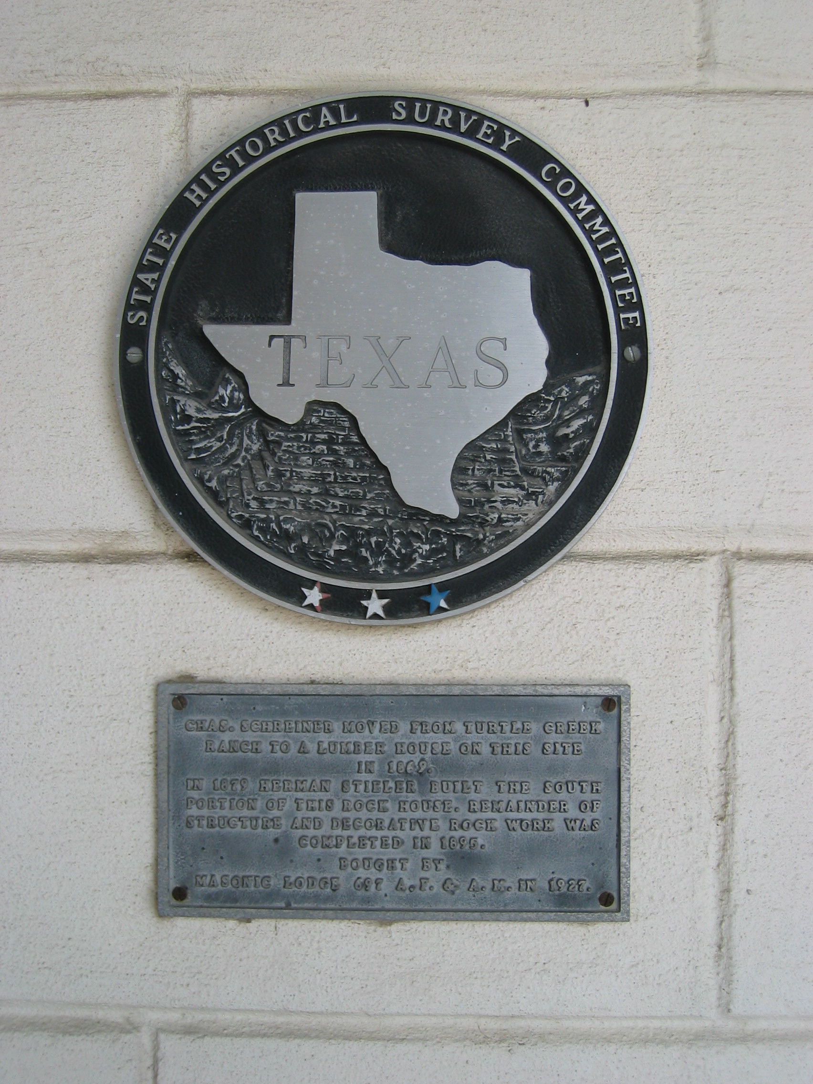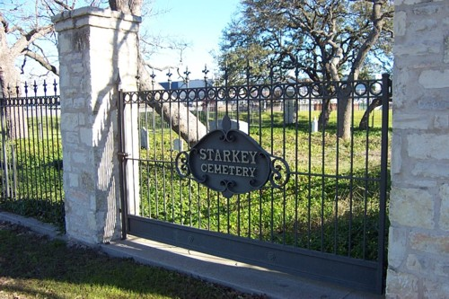
Photo by James R. Webb © 2004

Small cemetery with graves of early pioneer families. (2008)

Location: 1480 Junction Hwy next to Wal-Mart, Kerrville

GPS Coordinates: 30º03.669N & 99º10.067W

